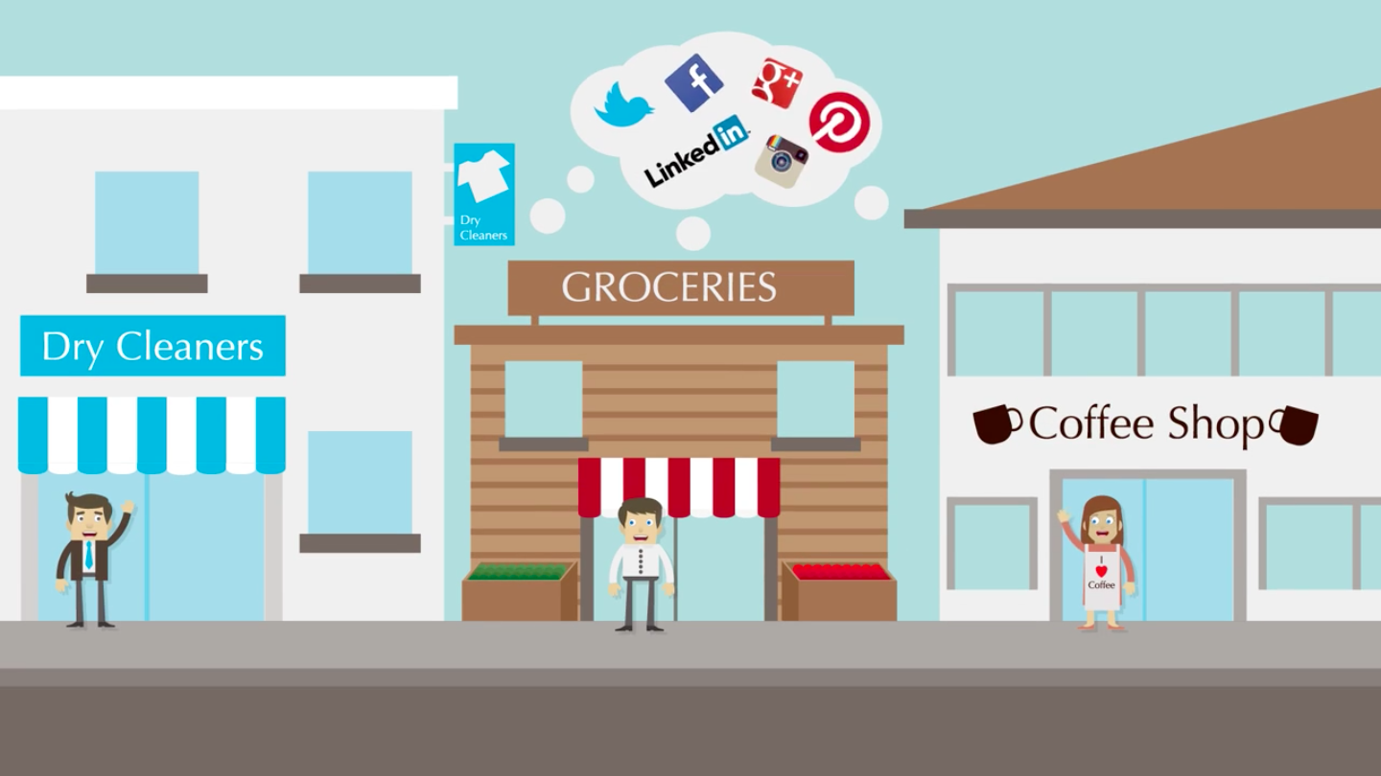  

**Social Media Marketing & Online Reputation Monitoring**

*Get more fans, followers, & customers.*

Our cutting edge social media tools and business solutions will grow your business online AND in-store.

Turn you online presence into a hub that attracts new and existing customers. With our engaging deals, sweepstakes, and online shopping solutions, you’ll always have something to promote that your customers want all while growing your email marketing list.

We help your business be seen and grow on social media by consistently posting new, engaging, and relevant content on your business’s Facebook, Twitter, and LinkedIn pages.

**555-555-5555 | www.YourWebsite.com | email@youremail.com**

We provide easy-to-understand analytics of your social media campaigns. From insights on individual posts to new likes and followers, you’ll be able to track the progress of your social efforts.

What are people finding about your business online? The majority of people rely on online reviews to make decisions on purchases. We help your business stay in a positive light with consumers.

_____________________________________________________________

Call: 555-555-5555 | Click: www.YourWebsite.Com| Email: email@youremail.com

**YOUR BUSINESS NAME**

**Grow Your Business With Social Media & Online Reputation Management**

## Social

## **Analytics**

## **Online**

## Review Monitoring

## Social Media

## **Management**

**Ready to get started?**

Don’t fall behind the competition. If you don’t have a hold of your social presence, you’re already at a competitive disadvantage. If you’re one of the millions of business owners who:

1. Don’t know how to drive sales through social media
2. Don’t have time to promote on social media
3. Don’t drive sales with your current social presence
4. Don’t know your business’s online reviews

***CONTACT US TODAY!***

…Over **ONE BILLION** active Facebook users per month.

…Over **300 MILLION** active Twitter users per month.

…**90%** of Yelp users say that reviews affect their purchases.

**Is Your Business**

**Getting Found**

**Online?**

**555-555-5555 | www.YourWebsite.com | email@youremail.com**

Open a new sales channel by selling your products online. Simple, safe, and secure. Sell everything from gift cards to an entire inventory of products. Easily customize pick-up and delivery options.

With our cutting edge technology, you can post reputable articles from all over the internet that are relevant to your business and advertise your business right on the article links.

Increase the number of new and returning customers with our customizable and engaging, enter-to-win sweepstakes and social deals. These tools will amplify your social marketing while building your email-marketing list.

## Shopping Carts **Online**

## Content

## **Banners**

## Social Deals &

## **Sweepstakes**

_____________________________________________________________

Call: 555-555-5555 | Click: www.YourWebsite.Com| Email: email@youremail.com

**Grow Your Business With Social Media & Online Reputation Management**

**YOUR BUSINESS NAME**