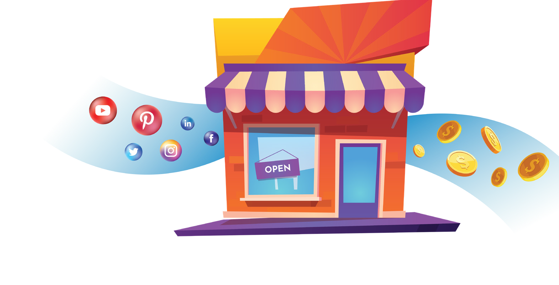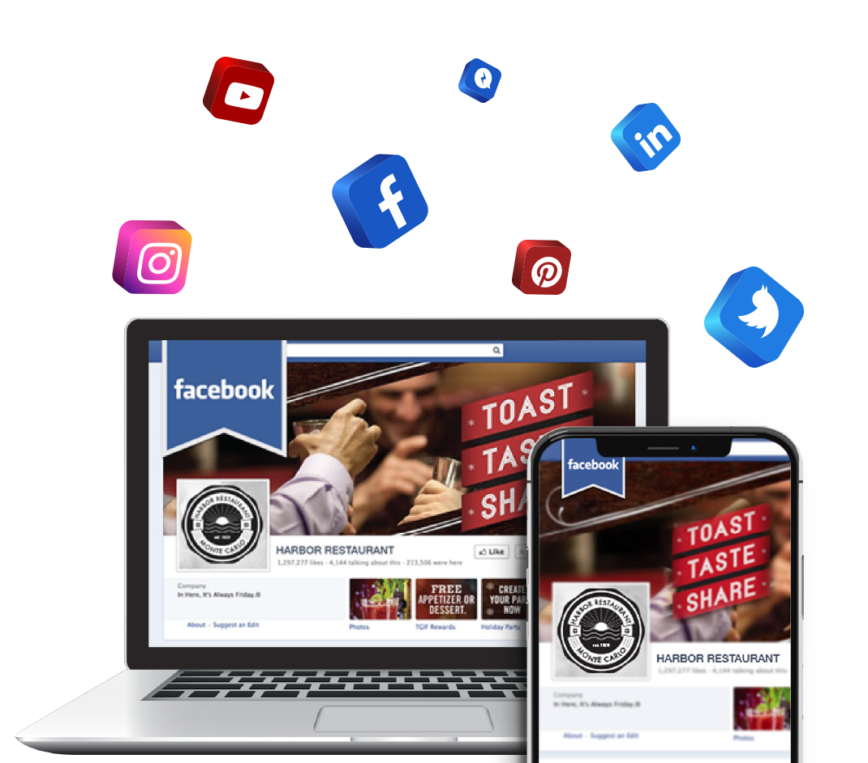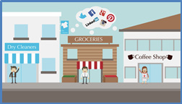

Turn-Key

**Social Media**

Marketing Business

Make Money Selling Social Media Services To Local Businesses

**SOCIAL MEDIA** MANAGEMENT

We help your business be seen and grow on

social media by consistently posting new, engaging, and relevant content on your business’s Facebook, Twitter, and LinkedIn pages.

**ONLINE REVIEW** MARKETING

What are people finding about your business online?

The majority of people rely on online reviews to make decisions on purchases. We help your business stay in a positive light with consumers.

SOCIAL **ANALYTICS**

We provide easy-to-understand analytics of your social

media campaigns. From insights on individual posts to new likes and followers, you’ll be able to track the progress of your social efforts.

555-555-5555 | [www.YourWebsite.com](http://www.YourWebsite.com/) | [email@youremail.com](mailto:email@youremail.com)

Call: 555-555-5555 | Click: [www.YourWebsite.Com|](http://www.YourWebsite.Com/) Email: [email@youremail.com](mailto:email@youremail.com)

**YOUR BUSINESS NAME**

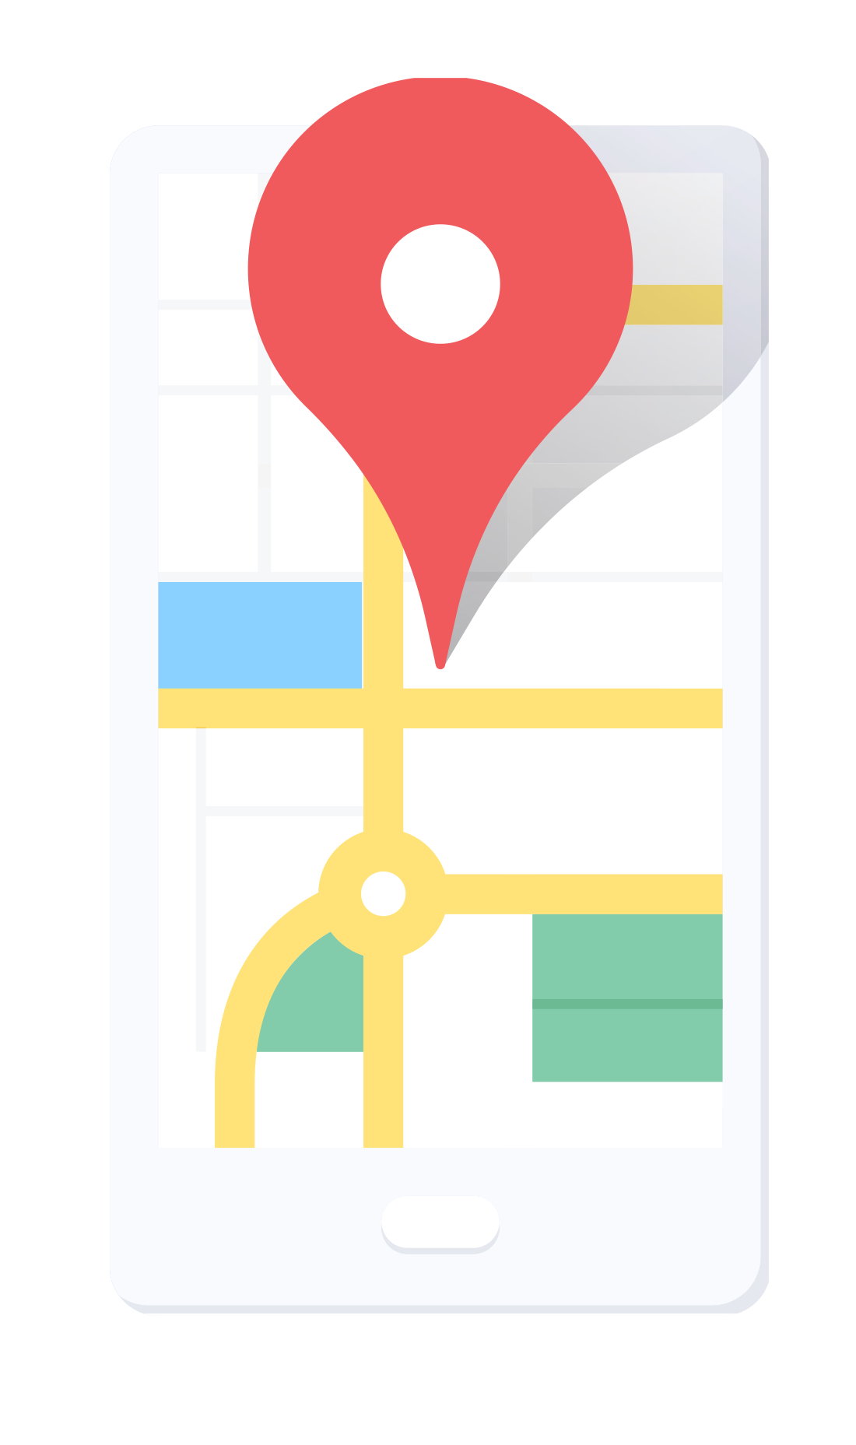

**Is Your Business Getting Noticed Online?**

Create Social Deals and Sweepstakes to improve customer retention and get new customers to act.

**YOUR BUSINESS NAME**

Call: 555-555-5555 | Click: [www.YourWebsite.Com|](http://www.YourWebsite.Com/) Email: [email@youremail.com](mailto:email@youremail.com)

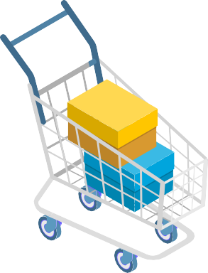

**SOCIAL DEALS** & **SWEEPSTAKES**

CONTENT **BANNERS**

With our cutting edge technology, you can pin a Banner Ad to your social media posts. This helps you get noticed and grow your email and/or text marketing subscriber list.

SHOPPING CARTS **ONLINE**

Open a new sales channel by selling your products online.

Simple, safe, and secure. Sell everything from gift cards to an entire inventory of products. Easily customize pick-up and delivery options.

**Ready to get started?**

Don’t fall behind the competition. If you don’t have a hold of your social presence, you’re already at

a competitive disadvantage. If you’re one of the

millions of business owners who:

1. Don’t know how to drive sales through social media
2. Don’t have time to promote on social media
3. Don’t drive sales with your current social presence
4. Don't actively manage your on-line reviews

***CONTACT US TODAY!***

…Over ONE BILLION active **Facebook** users per month.

…Over 300 MILLION active

**Twitter** users per month.

…90% of **Yelp** users say that reviews affect their purchases.

555-555-5555 | [www.YourWebsite.com](http://www.YourWebsite.com/) | [email@youremail.com](mailto:email@youremail.com)